**Macaw**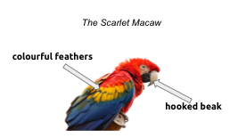

Macaws are the largest parrots in the world. The body of the macaw from **beak** to **tail** can be as long as 83 cm and can weigh between 129 and 169 grams. This beautiful macaw has bright **colourful feathers** covering most of its body, **wings** and long **tail.** The bird's strong **beak** is adapted to breaking hard nuts found in the rainforest.

The **scarlet macaw** can be found in Mexico, Peru, Brazil and the island of Trinidad. They prefer to spend their time in tall trees in forests and near rivers, usually in large groups.

Scarlet macaw’s diet includes **nuts, leaves, berries and seeds**. Its strong, hooked beak is perfect for breaking nuts and seeds. The scarlet macaw can eat fruits toxic enough to kill other animals, but they are okay!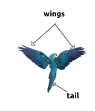

**wings**

**Why are the macaws endangered?**

The primary **threat** to the scarlet macaw is habitat **loss** from rainforest destruction. Poachers also hunt adult scarlet macaws for their meat. As more and more trees are being cut down, the scarlet macaws end up losing their homes. As fewer places will remain for the macaws to multiply, there will be a drop in the number of young ones that are raised.

**What you can do to help?**

You can help the macaw by not buying them as pets and protecting the rainforest from deforestation.

**Help Box   
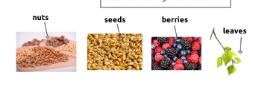**

| **threat=** an indication or warning of probable trouble, or of being at risk for something terrible  **loss=**  something that is lost |
| --- |

