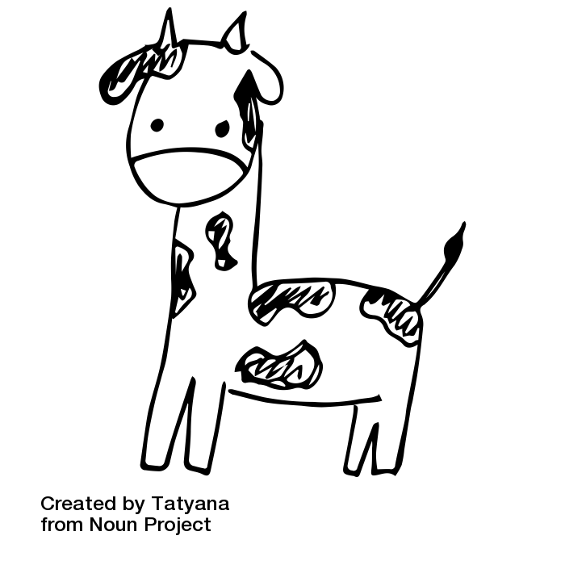tPREPARING TO CREATE A POSTER

In your poster you will need both images and words.

With your teammates, write down ideas of images and words you could use.

|  |  |  |
| --- | --- | --- |
| **IMAGES** |  | **WORDS** |
|  |  |  |



PREPARING TO CREATE A POSTER

In your poster you will need both images and words.

With your teammates, write down ideas of images and words you could use.

|  |  |  |
| --- | --- | --- |
| **IMAGES** |  | **WORDS** |
|  |  |  |