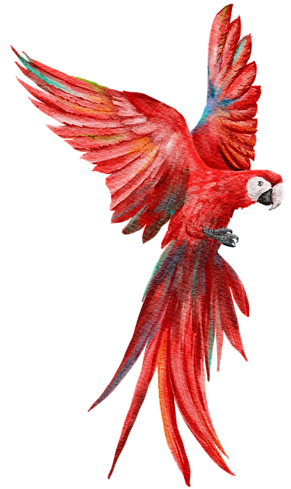 THE SCARLET MACAW - THE QUIZ

Write answer choices to complete these statements about the scarlet macaw.

Highlight the correct answers.

Statement 1:

The scarlet macaw is

* _____________________________________
* _____________________________________
* _____________________________________
* _____________________________________

Statement 2:

The scarlet macaw has

* _____________________________________
* _____________________________________
* _____________________________________
* _____________________________________

Statement 3:

The scarlet macaw lives

* _____________________________________
* _____________________________________
* _____________________________________
* _____________________________________

Statement 4:

The scarlet macaw eats

* _____________________________________
* _____________________________________
* _____________________________________
* _____________________________________

Statement 5:

The scarlet macaw ____________

* _____________________________________
* _____________________________________
* _____________________________________
* _____________________________________