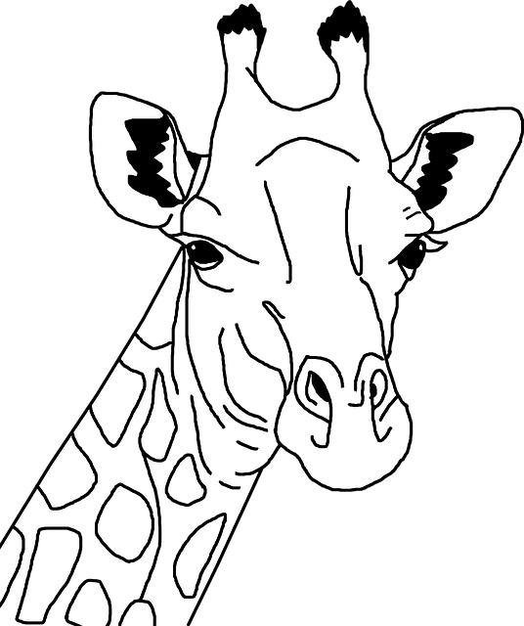 **WHAT DOES GIRAFFES THINK ABOUT?**

* Fill in the chart individually.
* Discuss with your partners and add new information to the chart.

| **K**  know | **W**  want to know | **L**  learned* |
| --- | --- | --- |
|  |  |  |

*Highlight the information that surprised you the most.

Use this information to write what the giraffe is thinking about.

____________________________________________________________________________



**WHAT DOES GIRAFFES THINK ABOUT?**

* Fill in the chart individually.
* Discuss with your partners and add new information to the chart.

| **K**  know | **W**  want to know | **L**  learned* |
| --- | --- | --- |
|  |  |  |

*Highlight the information that surprised you the most.

Use this information to write what the giraffe is thinking about.